Your First and Last Name Go Here
Mrs. Helton
English I CP
8 February 2016
MLA Formatting Rules and Guidelines for Your Research Paper
To begin, set up your paper as I have this page: size 12 Times New Roman Font, double spaced throughout, with your last name and page number inserted in the header (directions for achieving this in Google Drive can be found in the pages that follow). Make sure that you include the following in the four lines of the heading respectively: your first and last name, my name, the name of the course, and the date in MLA format. MLA format for the date is “day month year” in that order with absolutely no punctuation. When in doubt, try to make it look like I have it here. Your title will need to be centered in the line following your heading, and it must only be in plain text—no exceptions. Return to left alignment for the following line, tab in, and begin your introductory paragraph. You will need to tab in for each new paragraph. Do not add extra lines between any section of this paper; it is enough that it is already double spaced. Further directions for MLA formatting are on the pages that follow.

How to Format Your Paper in Google Docs
To insert a header (for your last name and page number):
- Go to the “insert” tab and click “header.”
- Go back to the “insert” tab and click “page number”; four options will pop up. Click on the top left hand option.
- Click behind/to the left of the number; type in your last name and a space.
- Click below the line of the header/in the body of your paper to leave the header.
To change alignment:
- Click on the appropriate tabs, denoted by the red arrows:
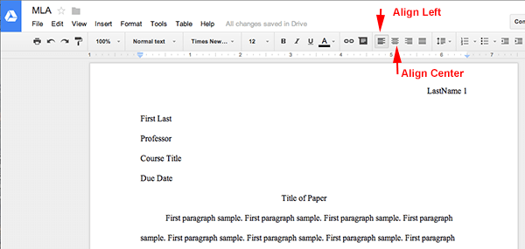

Formatting Your Quotations and In-Text Citations
If you know the author’s last name:
“Quote” (Author’s Last Name 103).
Your words “partial quote” your words (Author’s Last Name 45).
Paraphrased material (Author’s Last Name 78).
If you do not know the author’s last name:
“Quote” (“First Couple of Words from the Article Title” 18).
Your words “partial quote” (First Words of Book Title 62).
Paraphrased Material (“First Couple of Words from the Article Title” 5).
Rules:
- Place your in-text citation before punctuation—typically end punctuation.
  - “Quote” (citation), analysis.
  - “Quote” (citation); analysis.
  - “Quote” (citation). Analysis.
- Unless your quote ends in a question mark or exclamation point, do not include punctuation at the end of your quote/before your closing quotation marks. The punctuation will appear after your citation instead.
- Your in-text citations should not contain any punctuation inside the parentheses, unless you do not know the author’s last name and are using part of the title of an article or shorter work, which will need to appear in quotation marks.
  - Titles of major works will need to be italicized instead of in quotation marks.
- If you’ve already referenced the article and the author’s name (if applicable) in the sentence you are about to cite, you can end it with just the page number (766).
  - You can also do this if you are citing the same source multiple times in a row in a paragraph; use the last name or article title in the first citation and then use only the page number in the following citations.
- If you do not have a page number to cite (an online article that has no pagination, for example), use just the author’s last name in parentheses or the title if you do not know the author.
  - “Quote” (Author’s Last Name).
  - “Quote” (“Article Title”).
- If you need to change the tense or ending of a word from the original context of the quote to fit your essay (ran to run for example), denote the change by putting brackets around the [change].
  - “r[un]” (changing ran to run)
- Anything you include in your paper that you have discovered from research/another source must be cited. If you paraphrase something or quote something directly, follow it with a citation before the next point of punctuation.
  - It’s better to over-cite than to under-cite! If you do not cite, it is plagiarism (which results in a zero).
- Things that must go inside quotation marks: words you take directly from your source—even just one or two words; include them like “this” within your writing and then cite at the end of the sentence (Citation 45).
- If you paraphrase/fully transform the information into your own words, cite at the end of your paraphrasing and do not use quotation marks.
Next Installment: Works Cited Guidelines

Works Cited

